ML HW1

106598018 萬俊瑋

1.

|  |  |
| --- | --- |
| TP 99.9% | FP 0.1% |
| FN 0.1% | TN 99.9% |

For the sicker in group =0.01%

0.01%*99.9%/(0.01%*99.9%+99.99%*0.1%)=0.090834……≒9.1%

2.

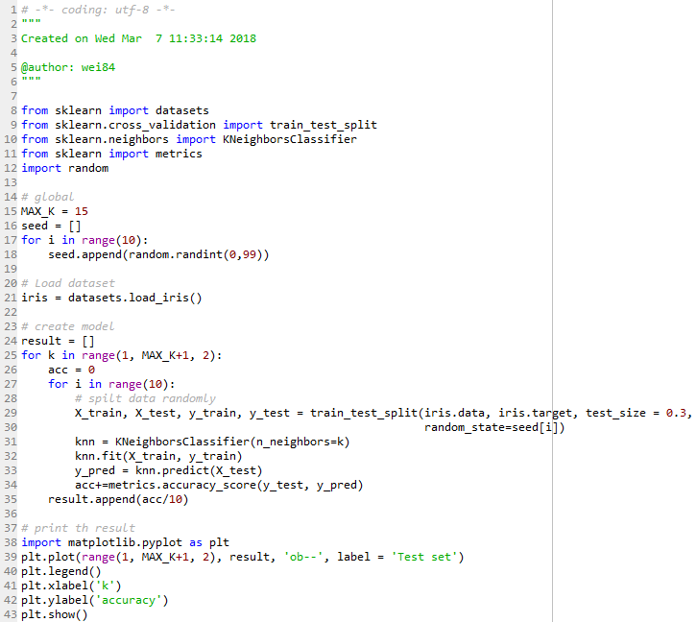

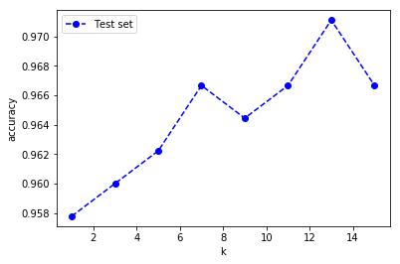

It seems that the best “k” is 13.

3.

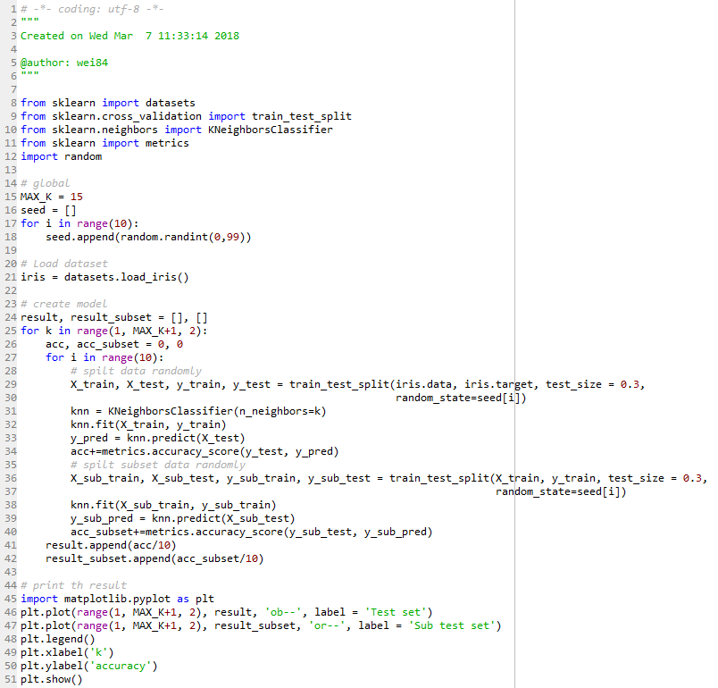

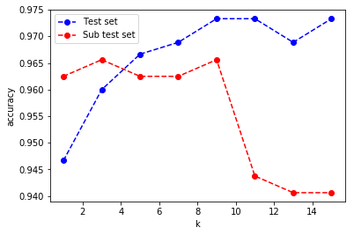

I use the 70% subset-data of origin data to spilt into 70% training set and 30% test set again, and run the KNN again to compare the result.

The best “ks” in origin data are 9, 11 and 15, and in subset are 3 and 11.

I run the same code in many times, I found the results are different in every time.

4.

<https://arxiv.org/ftp/arxiv/papers/1302/1302.4964.pdf>

We assume the feather of iris is normal distirbution, so we can do the naïve bayes classify via:

$$P(C=c|X=x)=\frac{P(C=c)P(X=x|C=c)}{P(X=x)}$$

Because we assume iris data is normal distirbution, we can get:

$$P\left(X=x | C=c\right)=\frac{1}{\sqrt{2πσ}}e^{-\frac{{(x-μ)}^{2}}{{2σ}^{2}}}$$

And, we can compute each probility of x in different class.

5.

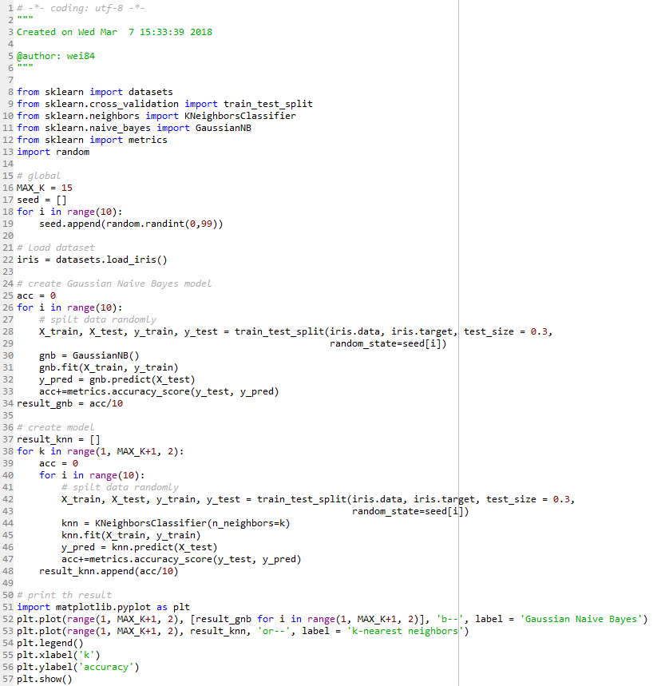

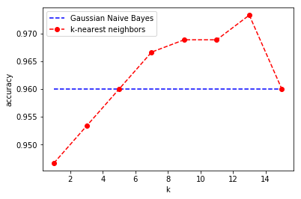

I found that most of time knn is beter than Gaussian Naive Bayes when k is big enough.